System Integration and Arch COMP851

Spring-2021

Saiteja Goud Voruganti (sv1081)

Github: <https://github.com/Saiteja2106/COMP851-PROJECT>

Data Stream 2:

I have chosen the Data Stream 2 part for the project which is the PTWC Widgets will be deployed into the field and communicate their GPS position.   In order to prepare field operations, we will need to establish a database which can determine the proximity of Widgets to county and township locations where field operators may be stationed, or sent.  In order to do this, we must deploy a GIS database, called PostGIS and ingest the city lat / long positions.  In addition, we must notify and record the ingest of these positions in preparation for the location of the field operators and Widget positions.  We must do so using the AWS SQS, and SNS/ SES interfaces in order to send the notifications and emails, and finally deposit log entries on s3.

Process flow using draw.io

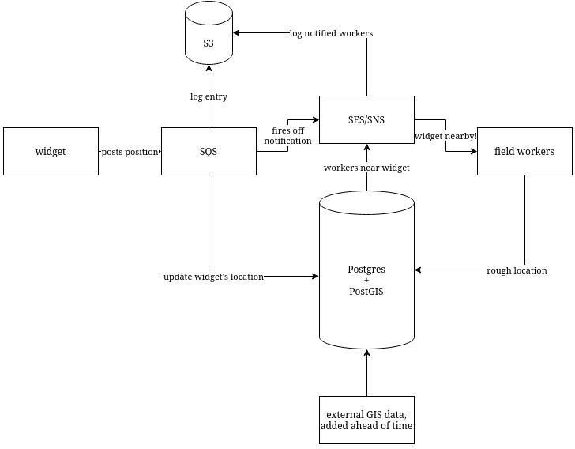

Implementation:

**Creating extension using postgis**

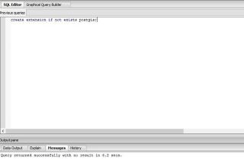

**Creating table landmarks**

|  |
| --- |
| CREATE TABLE landmarks |
|  | ( |
|  | gid serial NOT NULL, |
|  | name character varying(50), |
|  | address character varying(50), |
|  | date_built character varying(10), |
|  | architect character varying(50), |
|  | landmark character varying(10), |
|  | latitude double precision, |
|  | longitude double precision, |
|  | the_geom geometry, |
|  | CONSTRAINT landmarks_pkey PRIMARY KEY (gid), |
|  | CONSTRAINT enforce_dims_the_geom CHECK (st_ndims(the_geom) = 2), |
|  | CONSTRAINT enforce_geotype_geom CHECK (geometrytype(the_geom) = 'POINT'::text OR the_geom IS NULL), |
|  | CONSTRAINT enforce_srid_the_geom CHECK (st_srid(the_geom) = 4326) |
|  | ); |
|  |  |
|  | CREATE INDEX landmarks_the_geom_gist |
|  | ON landmarks |
|  | USING gist |
|  | (the_geom ); |

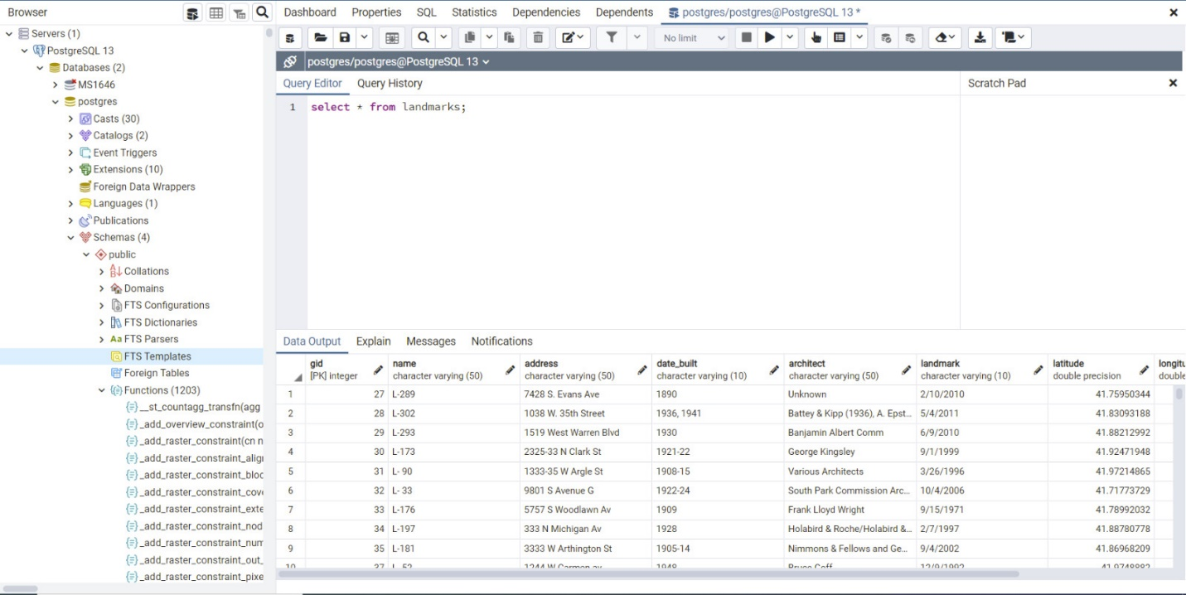

**Latitude and Longitude**

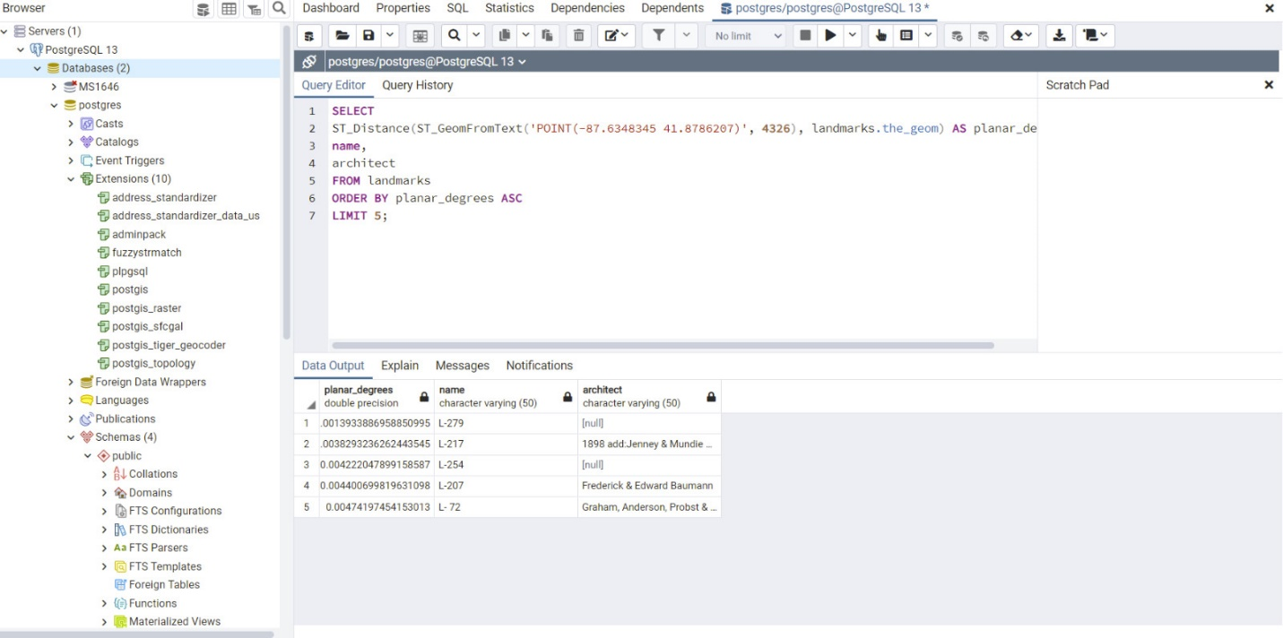

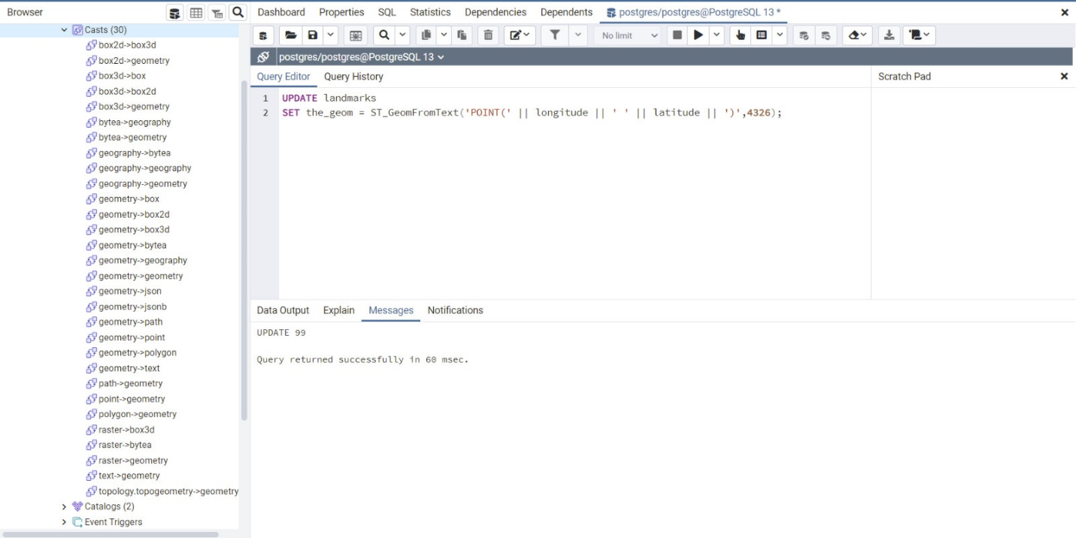

**Implementing the pythoncode and displaying:**

(base) unhmguest@unhmguest-Latitude-E6430:~$ python project.py

5 closest landmarks to -87.6348345 41.8786207

*******

Location-1

----------

Planar_Degrees - 0.0007463848779255456

Name - Brooks Building

Architect - Holabird & Roche

Latitude - 41.87787644

Longitude - -87.63477822

*******

Location-2

----------

Planar_Degrees - 0.0013933886958850995

Name - 300 West Adams Street Office Building

Architect - None

Latitude - 41.87972743

Longitude - -87.63568107

*******

Location-3

----------

Planar_Degrees - 0.0018793811696624153

Name - Continental And Commercial National Bank Building

Architect - None

Latitude - 41.87907898

Longitude - -87.63301185

*******

Location-4

----------

Planar_Degrees - 0.002712009853856664

Name - Chicago Board of Trade Building

Architect - Holabird & Root

Latitude - 41.87773513

Longitude - -87.63227115

*******

Location-5

----------

Planar_Degrees - 0.00307102762438656

Name - Rookery Building

Architect - Burnham & Root

Latitude - 41.87907613

Longitude - -87.63179743

*******

PostgreSQL connection is closed